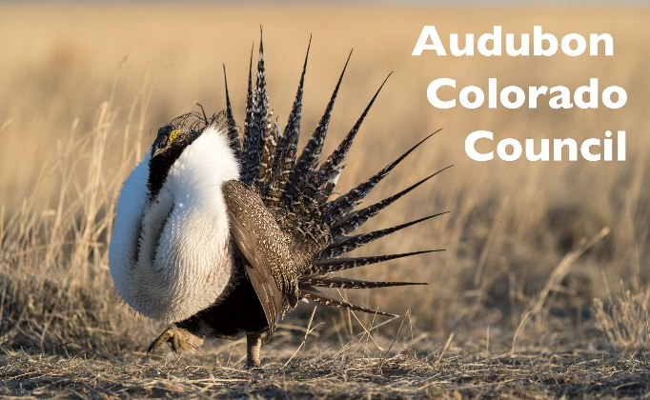
Lead Fact Sheet

- Humans face a potential risk of exposure to lead associated with eating wild game killed with lead bullets (CPW "Get the Lead Out"/CDPHE 2008).
- Lead has detrimental effects on the nervous and reproductive systems of mammals and birds.
- Eagles frequently scavenge carcasses of deer, elk and other wildlife that may harbor lead or lead fragments.
- Eagles with lead poisoning may exhibit loss of balance, gasping, tremors and impaired ability to fly.
- Emaciation follows and death can occur within 2 to 3 weeks after lead ingestion.
- Most hunters care about the health of Colorado's eagles and other wildlife.
- Non-lead bullets are available. Remington, Barnes, Federal, Winchester, Hornady, Nosler all make non-lead ammunition.
- Non-lead bullets are "extremely effective", "ensure the highest quality meat" and "prevent lethal collateral damage to wildlife"(huntingwithnonlead.org).

